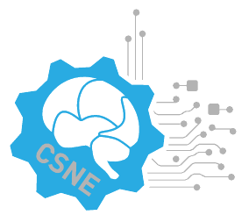 bA.

**NSF Engineering Research Center**

**for Sensorimotor Neural Engineering**

**CSNE Annual Review Site Visit Schedule**

**Mock Site Visit Review April 30, 2013**

**Location:**  CSNE Headquarters, 204 Russell Hall, 1414 NE 42nd St., Seattle, WA

8:05-9:00 Overview of the Center Tom Daniel, CSNE Interim Director

9:00-10:00 Research Program by Testbed (15 min + 5 min discussion each)

9:00-9:20 Closed-loop Brain-Controlled Interface: Rao/Kassegne

9:20-9:40 Closed-loop Prosthetic Limbs: Hannaford/Moon

9:40-10:00 Neuro-rehabilitation Systems: Moritz/Ozturk

10:00-10:15 Coffee Break

10:15-11:15 Research Program by Thrust (15 min + 5 min discussion each)

10:15-10:35 Reverse and Forward Engineering: Fairhall/Rieke

10:35-10:55 Control and Adaptation: Chizeck/Tedrake

10:55-11:15 Communication and Interface: Smith/Kassegne

11:15-12:30 Industrial/Practitioner Collaboration/Technology Transfer/Innovation: Rad Roberts

12:30 to 1:00 Lunch at the Center

1:00-2:00 University and Pre-college Education and Diversity (Education/Diversity Team)

Call-in Instructions

--------------------

Dial: (On campus) 7-9167

(Local) 206-897-9167

(Toll free) 1-866-495-7013